Module A.1: Simon Game Icebreaker

Akashdeep Rai

Level 0: Play the Simon Game

Game-play items

1. 7
2. 11
3. Simon allows us to use concentration because you have to concentrate on which color the light shows on which also can help you in learning in class to concentrate on your work.
4. Simon is similar to modern computer games such as bounce which you have to concentrate

Technical items

1. You must tap the correct colors in the same order the game shows you
2. The game plays a ring sound if you tapped the correct color in the correct order and plays a buzz sound if you tapped the wrong color
3. There is solo and pass it modes

Level 1: Simon History

Research

1. Ralph Baer created the Simon game
2. The Simon game was based on Simon Says
3. Magnavox odyssey was the first game system
4. Analogic, Submarine, and Table Tennis were the games created for the Magnavox odyssey

Discuss

1. The oldest game system which I had was a Nintendo 64
2. Current games are more clear than old games and current games have better mechanisms than old games
3. They both use the same strategies and some have the same story line and gameplay structures

Level 2: Output Analysis

1.

|  |  |  |
| --- | --- | --- |
| Object | Action | Description |
| Red Button | Push | Starts the game |
| Red Button | Push | Record a step in the pattern |
| Green Button | Push |  |
| Blue Button  Blue Button | Push  Push | Game setting/selector  Skill Level |
| Yellow button | Push | Ends game |

2.

|  |  |  |
| --- | --- | --- |
| Object | Action | Description |
| Red light | Flash | Indicates a step in the pattern |
| Red sound | Play tone | Indicates a step in the pattern |
| Green light | Flash | Indicates a step in the pattern |
| Green Sound | Play tone | Indicates a step in the pattern |
| Blue light | Flash | Indicates a step in the pattern |
| Blue sound | Play tone | Indicates a step in the pattern |
| Yellow light | Flash | Indicates a step in the pattern |
| Yellow sound | play tone | Indicates a step in the pattern |

3.

|  |  |  |
| --- | --- | --- |
| Object | Action | Description |
| Red Button | Red Light | Flashes when button is pushed and makes a sound |
| Green Button | Green Light | Flashes when button is pushed and makes a sound |
| Blue Button | Blue Light | Flashes when button is pushed and makes a sound |
| Yellow Button | Yellow Light | Flashes when button is pushed and makes a sound |

Level 3: Flowchart Conventions

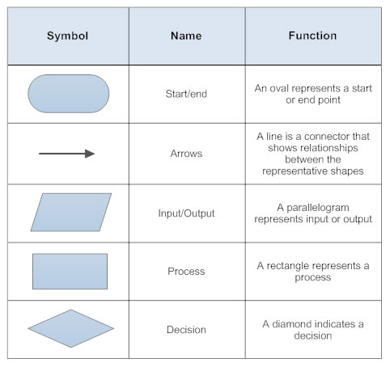

2.

Level 4:Flowchart the Simon Game

